NORTHWIND SCHEMA:

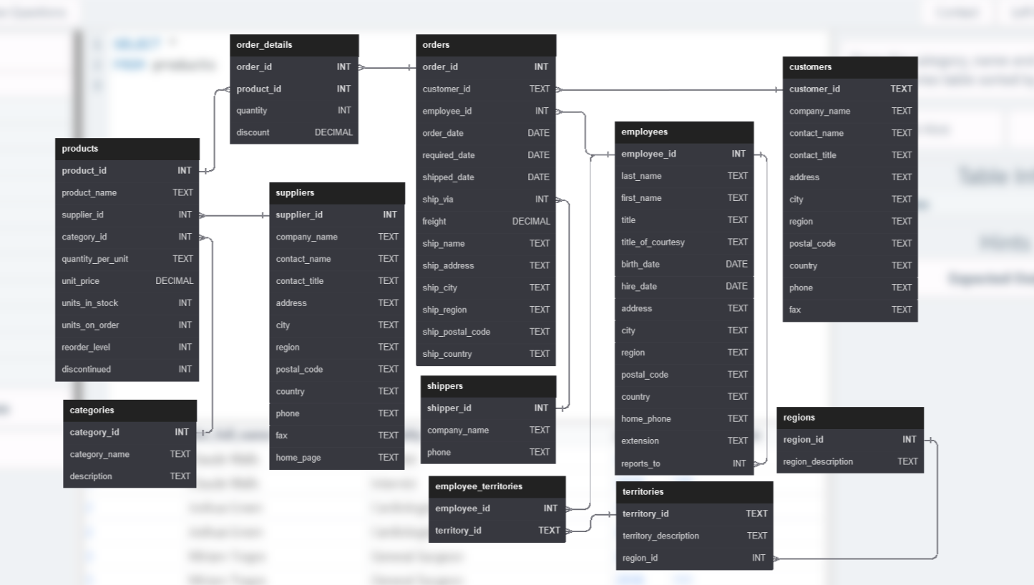

EASY QUESTIONS:

1. **Show the category_name and description from the categories table sorted by category_name.**

* SELECT category_name,description

FROM categories

order by category_name;

1. **Show all the contact_name, address, city of all customers which are not from 'Germany', 'Mexico', 'Spain'**

* SELECT contact_name, address,city

FROM customers

WHERE

country not in ('Germany', 'Mexico', 'Spain');

1. **Show order_date, shipped_date, customer_id, Freight of all orders placed on 2018 Feb 26**

* SELECT order_date, shipped_date, customer_id, freight

from orders

where order_date ='2018-02-26';

1. **Show the employee_id, order_id, customer_id, required_date, shipped_date from all orders shipped later than the required date**

* SELECT employee_id, order_id, customer_id, required_date, shipped_date

from orders

where shipped_date > required_date;

1. **Show all the even numbered Order_id from the orders table**

* SELECt order_id

from orders

where order_id % 2 = 0;

1. **Show the city, company_name, contact_name of all customers from cities which contains the letter 'L' in the city name, sorted by contact_name**

* SELECt city, company_name, contact_name

from customers

where city like '%L%'

order by contact_name;

1. **Show the company_name, contact_name, fax number of all customers that has a fax number. (not null)**

* SELECt company_name, contact_name, fax

from customers

where fax IS NOT null;

1. **Show the first_name, last_name. hire_date of the most recently hired employee.**

* SELECt first_name, last_name, hire_date

from employees

where hire_date IN (select max(hire_date) from employees);

OR

* SELECt first_name, last_name, max(hire_date) as hire_date

from employees;

1. **Show the average unit price rounded to 2 decimal places, the total units in stock, total discontinued products from the products table.**

* SELECt round(avg(unit_price),2) as avg_unit_price,

sum(units_in_stock) as total_units_in_stock,

sum(discontinued) as total_discontinued_products

from products;

MEDIUM QUESTIONS:

1. **Show the ProductName, CompanyName, CategoryName from the products, suppliers, and categories table**

* SELECt p.product_name, s.company_name, ca.category_name

from products p join categories ca

on p.category_id=ca.category_id

join suppliers s

on p.supplier_id=s.supplier_id;

1. **Show the category_name and the average product unit price for each category rounded to 2 decimal places.**

* SELECt c.category_name,

round(avg(p.unit_price),2) as avg_prod_unit_price

from products p join categories c

on p.category_id=c.category_id

group by c.category_name;

1. **Show the city, company_name, contact_name from the customers and suppliers table merged together.  
   Create a column which contains 'customers' or 'suppliers' depending on the table it came from.**

* SELECt city, company_name, contact_name, 'customers' as tablename from customers

union

select city, company_name, contact_name, 'suppliers' as tablename from suppliers;

HARD QUESTIONS:

1. **Show the employee's first_name and last_name, a "num_orders" column with a count of the orders taken, and a column called "Shipped" that displays "On Time" if the order shipped_date is less or equal to the required_date, "Late" if the order shipped late.  
     
   Order by employee last_name, then by first_name, and then descending by number of orders.**

* SELECt e.first_name, e.last_name,

count(o.order_id) as num_orders,

(case

when o.shipped_date <= o.required_date then 'On Time'

else 'Late'

end) as shipped

from employees e join orders o

on e.employee_id=o.employee_id

group by o.employee_id,shipped

order by e.last_name, e.first_name,num_orders desc;

1. **Show how much money the company lost due to giving discounts each year, order the years from most recent to least recent. Round to 2 decimal places.**

* SELECt year(order_date),

round(SUM(p.unit_price*od.quantity*od.discount),2) as money_lost

from order_details od join orders o

on od.order_id=o.order_id

join products p

on od.product_id=p.product_id

group by year(order_date)

order by year(order_date) desc;